HEROIN IN BOOK BINDINGS IN FORT LAUDERDALE, FLORIDA
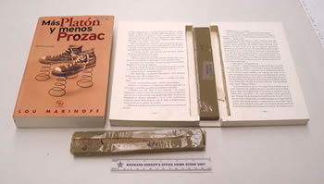
Photo 1
The Broward Sheriff's Office Crime Laboratory (Ft. Lauderdale, Florida) recently received two books entitled: "Mas Platon y Menos Prozac" (roughly: "More Support and Less Prozac"). Both books contained a rectangular chunk of compressed, brown colored powder (wrapped in clear plastic) in a cut-out area of their bindings, suspected heroin (see Photo 1, above). The books were mailed to a Fort Lauderdale address by an express delivery service, and were intercepted (and a controlled delivery performed) by the Broward Sheriff's Office. Analysis of the powder (total net mass 99.0 grams) by crystal testing and GC/MS confirmed heroin (quantitation not performed, but the analysis suggested high purity). This is the first time this smuggling technique has been encountered by the Crime Laboratory.
LIQUID COCAINE INSIDE THE LININGS OF PLASTIC MUGS
IN MIAMI, FLORIDA
The DEA Southeast Laboratory (Miami, Florida) recently received six colored acrylic/plastic mugs containing liquid inside the linings, suspected liquid cocaine (see Photo 3). The mugs (three gray/blue, two clear, and one red/pink) were contained in an express mail package, and were intercepted by DEA Miami at the Miami International Airport Foreign Mail Facility. Analysis of the liquid (total net volume 1331 milliliters) by GC, GC/MS, IR, color testing, and anion testing confirmed 53 percent cocaine hydrochloride (610 milligrams/milliliter). This is the first encounter with this type of smuggling technique by the Southeast Laboratory.
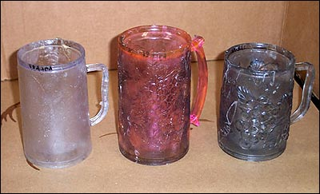

SALVIA DIVINORUM IN MIAMI-DADE COUNTY, FLORIDA
The Miami-Dade Police Department Crime Laboratory Bureau (Miami, Florida) recently received a submission of 0.4 grams of dried, partially crushed plant material, dark green in color, suspected Salvia Divinorum (see Photo 7). The material was seized by a Miami-Dade County Public Schools police officer from a student. Microscopic examination showed none of the characteristics of marijuana, and the modified Duquenois-Levine test gave a wine-red color that did not transfer to chloroform. Extraction following the procedure by Giroud, et al. (Forensic Science International 2000;112(2-3):143) followed by GC/MS analysis confirmed salvinorin A, the psychoactive component in salvia divinorum. Purchased salvia divinorum containing artificially enhanced concentrations of salvinorin A (10X) was used as a comparison standard, and was extracted and analyzed in the same manner. This is the Crime Laboratory's first encounter with this material.
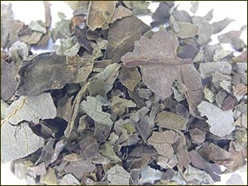 Photo 7
[Editor's Notes: This is the first mention (in Microgram Bulletin) of salvia divinorum containing artificially enhanced concentrations of salvinorin A. According to the analyst, the source now provides salvia divinorum containing up to 15X enhancement of salvinorin A. Further details not provided in accordance with Journal policy (crime laboratories with a legitimate need to know may contact the Editor for additional information). A comprehensive Selected Intelligence Brief on Salvia Divinorum (published by the National Drug Intelligence Center (NDIC)) was reprinted in the June 2003 issue of Microgram Bulletin.]
CHOCOLATE/PSILOCYBIN "LOLLIPOP" IN TAMPA, FLORIDA
The Florida Department of Law Enforcement Tampa Crime Laboratory (Tampa, Florida) recently received an unusual submission of a chocolate lollipop from the Tampa Police Department. The evidence was recovered at a Grateful Dead Concert in Tampa, and was submitted as a suspected chocolate/psilocybin mushroom concoction. The lollipop was cellophane wrapped, about 6 x 4 centimeters in size (candy only), weighed 27.4 grams (including the stick), and looked and smelled like chocolate candy (see Photo 2). However, pieces of fibrous material (presumed ground psilocybin mushroom) were visible throughout the chocolate when the lollipop was broken (see Photo 3). Acid/base workup followed by analysis of an extract by GC and GC/MS confirmed psilocin. Extraction of a separate sample of the exhibit with methanol, followed by preparatory TLC, followed by standard TLC, confirmed psilocin (quantitation not performed). Of note, there was no indication of psilocybin in the sample. This was the first encounter with a chocolate/psilocybin (psilocin) concoction by the Laboratory. [Editor's Note: Numerous additional examples of chocolate/psilocybin mushroom concoctions were reported in the May, June, and August 2003 issues of Microgram Bulletin.]
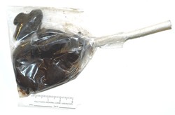 | 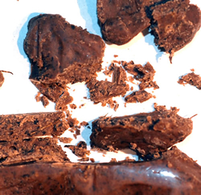
* * * * *
WET COCAINE IN LOTION BOTTLES FROM JAMAICA
The DEA Mid-Atlantic Laboratory (Largo, Maryland) recently received five different varieties of "lotion" bottles, each containing a plastic bag of pasty white material, suspected wet cocaine (see Photo 4, below). The exhibits were seized by the United States Customs Service at the Baltimore-Washington International (BWI) Airport. Analysis of the exhibit (total net mass from the bottles was 881.4 grams) by color testing, GC, GC/MS, and FT-IR confirmed 59 percent cocaine hydrochloride. This was the laboratory's first encounter with this type of smuggling technique.

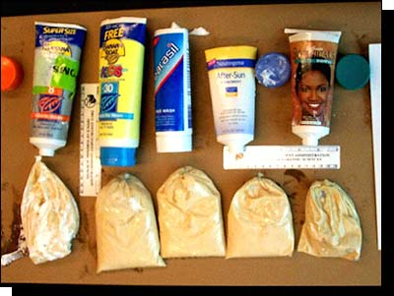
Photo 4

- INTELLIGENCE ALERT -
COCAINE IMPREGNATED SILICONE IN BASEBALL CAP PARTS IN PERU
The DEA Southwest Laboratory (Vista, California) recently received an unusual suspected cocaine smuggling exhibit consisting of apparent fabric cuttings used to make baseball style caps, specifically, 19 off-white pieces that would compose the round part of the hat (total net mass 852 grams), and 18 black nylon covered pieces in a crescent moon shape that would become the visor (see Photo 1 for reconstructed cap). The items were originally seized by the Peruvian National Police (PNP), and had been in a package intended to be mailed from Lima to Hawaii. Analysis by PNP chemists indicated that cocaine was present only in the white pieces. After DEA agents performed a controlled delivery in Hawaii, the evidence was forwarded to the Southwest Laboratory for further analysis. The items had only a faint odor of acetic acid but tested positive for cocaine using the nonacidic cobalt thiocyanate reagent. After several experiments, chloroform was determined to be the best solvent for extraction of the cocaine from the matrix. The "fabric" became transparent after soaking in chloroform for 18 hours, yielding a rubbery material that is suspected to be a silicone caulk type substance (see Photo 2). The material was quantitated to be 47 percent cocaine HCl by weight (equal to 370 grams of pure cocaine HCl).
[Editor's Notes: According to the suspect, the Peruvian chemist responsible for preparing the material has been in operation for three - four years, has fabricated various other common items using the cocaine-silicone mixture (including wetsuits and suitcase liners), and expects the mixture to become a new method for smuggling drugs into the US and Europe. He also indicated that the items are usually mailed, and are also usually sprayed with pepper spray to deter canines. It is worth noting that curing silicone usually has an odor of acetic acid.]
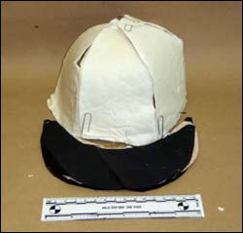 | 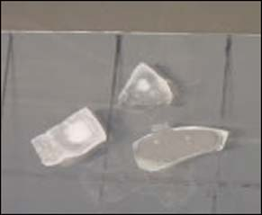
Photo 1 | Photo 2
* * * * *
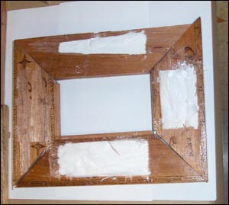
Photo 4
FENTANYL TABLETS IN POLK COUNTY, FLORIDA
The Florida Department of Law Enforcement Tampa Crime Laboratory recently received a polydrug submission from the Polk County Sheriff's Office that included two "home-made", light green tablets, allegedly a mixture "kind of like Soma and Valium". The tablets were seized during a probation check from a local drug user who is a so-called "Mikey" (a volunteer "guinea pig" who is willing to "test" (by self-administration) illicit drugs and drug mixtures of virtually any type). Other drugs seized in the same case included methamphetamine residue on charred foil, lorazepam powder and tablet fragments, a methadone tablet, and possible tramadone tablets (the latter were not analyzed, but were tentatively identified by tablet markings). The home-made tablets were unmarked, half-scored on one face, 12 millimeters in diameter, and had an average weight of 600 milligrams (see Photo 5). Preliminary analysis of a chloroform extract of one quarter of a tablet (from a 5% NaHC03 solution) by GC/MS suggested fentanyl. Analysis of a methanol extract (1 mL) of the remaining three-fourths of the tablet by GC and GC/MS confirmed fentanyl (quantitation not performed). This is the first time a tablet preparation of fentanyl has been encountered by the Laboratory.
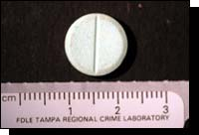
Photo 5
- INTELLIGENCE ALERT -
WOODEN PICTURE FRAMES CONTAINING COCAINE HCI IN MIAMI, FLORIDA
The DEA Southeast Laboratory (Miami, Florida) recently received a submission consisting of seven brown, wooden picture frames which included plastic bags containing white powder hidden within internal cavities, suspected cocaine (see Photo 4). The frames (dimensions 24 x 18 x 1.5 centimeters) had been mailed via Federal Express, and were seized by the DEA Miami Field Division personnel at the U.S. Customs Foreign Mail Facility in Miami. Each frame had a different inscription in Spanish, for example “Para Alguien muy Especial” (“For Someone Very Special”). Analysis of the powder (total net weight 948.9 grams) by GC-FID, GC/MS, and IR confirmed 97 percent cocaine hydrochloride. This was the first submission of this type to the laboratory.
INTELLIGENCE BRIEF -
MDMA MIMIC TABLETS CONTAINING PCP IN ORLANDO, FLORIDA
The Florida Department of Law Enforcement (FDLE) Orlando Regional Crime Laboratory recently received a submission of 137.7 grams of blue and 33.2 grams of green tablets, 9 millimeters in diameter, with an elevated cross on one side and single-scored on the reverse (see Photo 7), and 23.3 grams of yellow tablets, 11 millimeters in diameter, with the ying/yang symbol on one side (see Photo 8), all suspected Ecstasy. The numbers of tablets were not determined; however, the blue and green "cross" tablets weighed approximated 270 milligrams each, while the yellow "ying/yang" tablets weighed approximately 360 milligrams each. The exhibits were seized by the Orange County Sheriff's Office as a result of a buy/bust operation in the Pine Hills area of Orlando. Analysis of the blue and green "cross" tablets by GC/MS, however, indicated not MDMA but rather phencyclidine (PCP). The amount of PCP was not quantitated; however, the green tablets had approximately three times as much PCP as the blue tablets. Analysis of the yellow "ying-yang" tablets by GC/MS indicated an approximate 3:1 mixture of MDA and methamphetamine (exact quantitation not performed) This is the first time this laboratory has seen "cross" logo PCP tablets.
- INTELLIGENCE ALERT -
HEROIN IN THE FOAM BACKING OF A WOODEN TRAY TABLE SEIZED IN MIAMI, FLORIDA
The DEA Northeast Laboratory (New York, New York) recently received a multi-part submission consisting of a large, decorated, wooden coffee tray with fold-down legs, plus four pictures mounted on wood (see Photo 1, note the clear, one foot long ruler leaning against the back edge of the tray), suspected as containing heroin. The exhibits were initially seized by the Immigration and Customs Enforcement Service Miami, Florida Office from a Federal Express shipment (origin not reported), and were submitted to the laboratory after an attempted controlled delivery in the New York City area. The pictures did not contain any controlled substances; however, the tray contained a backing of yellow rubberized foam that field-tested positive for heroin (see Photo 2). Analysis of the foam (total net mass 333.6 grams) by GC-FID, GC/MS, and FT-IR confirmed 86 percent heroin hydrochloride. The laboratory has previously received foam and rubberized mats containing heroin, but never before as part of a tray table.
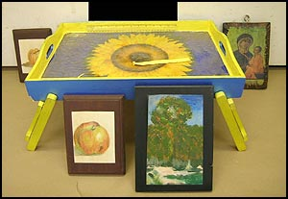
Photo 1
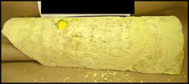
Photo 2
[Editor’s Notes: Previous “heroin foam” exhibits have all derived from South American processors. 86 percent heroin in a foam sample is unusually high, and suggests a possible breakthrough in this technology.]

INTELLIGENCE ALERT -
HARD-COVER BOOKS CONTAINING COCAINE IN NEW YORK, NEW YORK
The DEA Northeast Laboratory (New York, New York) recently received six hard cover books with hidden (hollowed-out) compartments in each cover, all containing strip packages of white powder, suspected cocaine. The books (dimensions 9.5 x 11 or 12 inches, width not reported) were seized in New York City by agents from the New York Division (see Photo 9). The titles (all Spanish) included five books in the “History of Mankind” series, and also “Diana, Princess of Wales - A Life in Pictures”. The insides of each cover were sealed with paper to conceal the hollowed-out compartments. Analysis of the powder (total net mass 1.18 kilograms) by GC/FID, GC/MS, and FTIR confirmed 86 percent cocaine hydrochloride. The Northeast Laboratory routinely receives cocaine smuggled in different consumer and manufacturing items.
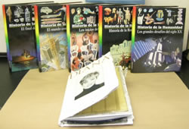
Photo 9

INTELLIGENCE ALERT -
NESTLE SUPLIGEN® CANS CONTAINING LIQUID
COCAINE IN PLANTATION, FLORIDA
The DEA Southeast Laboratory (Miami, Florida) recently received seven commercially labelled cardboard boxes containing 288 cans of Nestle's Supligen® (a dietary supplement drink), suspected to contain solutions of cocaine (see Photo 12). The exhibits were seized from a storage facility in Plantation by agents from the DEA Fort Lauderdale District Office (Plantation is located just west of Fort Lauderdale). Ninety two of the cans contained a thick, clear liquid (total net mass 38.66 kilograms (total net volume 31.69 liters)) that screened positively for cocaine. Analysis by GC, FTIR, and GC/MS confirmed a mixture of cocaine hydrochloride (753 mg/mL) and phenacetin (not quantitated). This was the first submission of liquid cocaine in cans of Supligen to the laboratory.
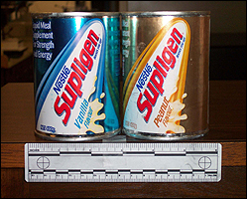
Photo 12
VERY LARGE SEIZURE OF COCAINE BASE MADE OFF THE WEST COAST
OF SOUTH AMERICA
The DEA Southwest Laboratory (Vista, California) recently received an unusual exhibit consisting of 1832 individual packages of a variety of dimensions and weights, containing an off-white waxy material (total net mass approximately 3500 kilograms), suspected cocaine (see Photo 6). The exhibit was seized by the U.S. Coast Guard from a vessel in international waters off the western coast of South America. The packages were in three general shapes:
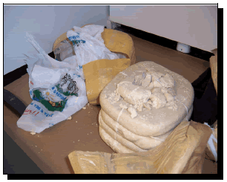
Photo 6
Single bricks approximately 7 x 3.5 x 1.5 inches; double bricks approximately 9 x 3 x 3 inches; and rounded cubes approximately 7.5 x 7.5 x 5 inches. The non-standard shapes of the packages and the physical consistency of the substance suggested that the material was not cocaine hydrochloride. This was confirmed when there was essentially no response with the non-acidified cobalt thiocyanate reagent, but a very strong positive was observed with the acidified cobalt thiocyanate reagent. Analysis by IR and GC indicated 86 percent cocaine base. Unusually, the exhibit did not contain sodium bicarbonate or any other material commonly used to convert cocaine hydrochloride to cocaine base. This is the largest seizure of cocaine base ever received by the Southwest Laboratory.

12 Babies Rented Out by Mothers to Drug Smugglers as Decoys
Another Defendant Convicted in Case
CHICAGO, IL - The sentencing of Van Burn Flowers to nine years imprisonment yesterday resurrected the horrors of a past DEA case. Flowers, a member of a multi-million dollar cocaine and heroin distribution network based in the South-side Chicago neighborhood of Englewood, used the wholesome image of infants to mask smuggling transports to the United States and the United Kingdom. Between 1996 and 1999, young female couriers, posing as mothers with babies, smuggled cocaine and heroin for the distribution ring. What that proved most shocking was that some of the babies used in the ruse were rented from their parents and shipped abroad as cover for the liquid cocaine and heroin being smuggled in baby formula cans and body cavities.
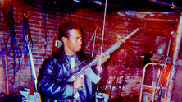
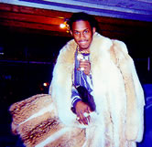
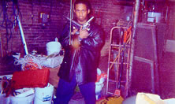
Drug smuggling operative Sylvester Thomas shows off weapons and material items gained through the exploitation of infants as part of the 'Baby Formula' cocaine and heroin smuggling network. Thomas received a sentence of Life in Prison for his role in the organization.
In the roughly 45 trips documented by the government, 22 babies where utilized as covert cover for drug shipments, 12 of whom where actually rented to drug couriers by their own parents in exchange for cash or drugs. Members of the conspiracy decided to smuggle cocaine into the United States from Panama by having women travel with babies carrying baby formula cans filled with liquid cocaine, believing that they would be successful because the women would not appear suspicious to U.S. Customs Service officers. The couriers were paid to travel from Chicago to Panama with the rented babies, to pick up the cocaine-filled baby formula cans in Panama, and then return to the U.S. with the babies and the cocaine, posing as mothers simply carrying food for their babies.
The majority of the drugs in this case were distributed in Chicago and New York, while some of the cocaine-filled baby formula cans were exported to the United Kingdom in a designed attempt to expand the smuggling scheme to Europe. Utilizing the same ruse, and some of the same women couriers and babies, cocaine from the organization was distributed to illicit-drug buyers in London and Birmingham, England.
Clancy Watson Herrera, who is currently in custody in Panama, supplied cocaine and heroin to the conspiracy from Panama, and Byron Watson, of Montego Bay, Jamaica, supplied cocaine and heroin to the conspiracy from Panama and Jamaica. Herrera and Orville Wilson, of New York, originated the idea of having female couriers traveling with babies smuggle liquid cocaine in baby formula cans into the United States. Herrera, Watson and other co-conspirators liquefied the cocaine by adding hot water to it and putting it in a blender. They removed the labels from the baby formula cans and created a hold in the cans with a hammer and nail. They inserted the liquid cocaine in the cans with a syringe, soldered up the holes, and re-attached the labels to the cans.
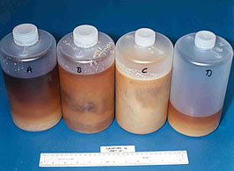
Liquid cocaine seized during the case in evidence storage bottles.
The couriers also smuggled cocaine and heroin into the United States from Panama and Jamaica by inserting the drugs into their body cavities before boarding their return flight to the United States. This organization also used a variety of illegal schemes to support their operation, including the acquisition of fraudulent U.S. passports and using bogus airlines tickets utilizing travel agent access to defraud the airline industry of an estimated $500,000.00.
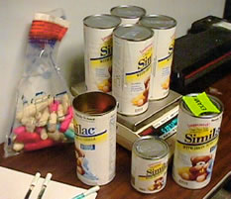
Seized pellets of heroin and baby formula cans used to smuggle cocaine.
The successful prosecution of this case was the result of an existing DEA case being merged with evidence provided by the vigilant discovery of Customs Inspectors. Combining the DEA case and the Customs case under the umbrella of one investigation was essential in ending this disturbing drug smuggling method and bringing those responsible to justice.
The DEA would again like to commend the extensive cooperation among local, federal and foreign lawn enforcement agencies that participated in the investigation. Specifically, the Bureau of Immigration and Customs Enforcement (BICE), the Chicago Police Department, the New York Police Department, British Customs, formally known as Her Majesty’s Customs and Excise Law Enforcement Directorate, the National Police Department of Panama, the Royal Canadian Mounted Police, The U.S. State Department’s Passport Office, and local police departments of Oak Lawn, Willow Springs, Bridgeview and Palos Hills, Illinois.
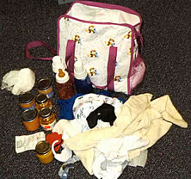
Baby bag and bottles used by drug couriers.
The defendants were charged and prosecuted by the Assistant United States Attorney’s Office for the Northern District of Illinois. The defendants face mandatory minimum sentences of either five or ten years in prison and maximum prison terms of either 40 years or life, and various fines ranging as high as four million dollars. The United States Court determines the appropriate sentence to be imposed under the United States Sentencing Guidelines.

